HealthCure: Online Health Management

Entities:
- Admin
- Doctors
- Patients
Controllers Implemented:
- Admin
- Patients
- Doctors
- Appointments
Functionalities of each controller:
- Admin: - Admin is the authorized one. Admin can retrieve patient’s details and can add, update and delete doctor’s data. Also, Admin can retrieve appointment data from model.

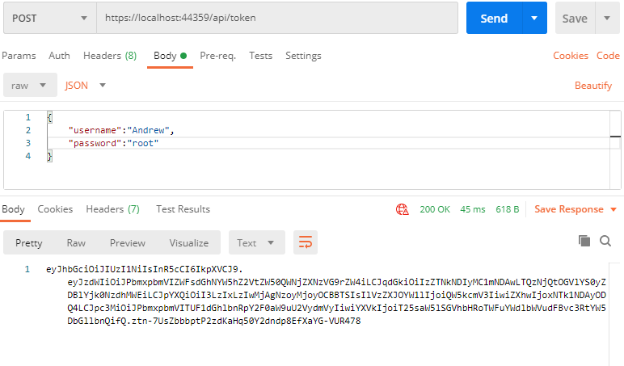 Fig: Admin controller checks the admin details entered are correct.

- Patients: - Patient Controller can retrieve data of patients from models and returns proper view and its associated view data.
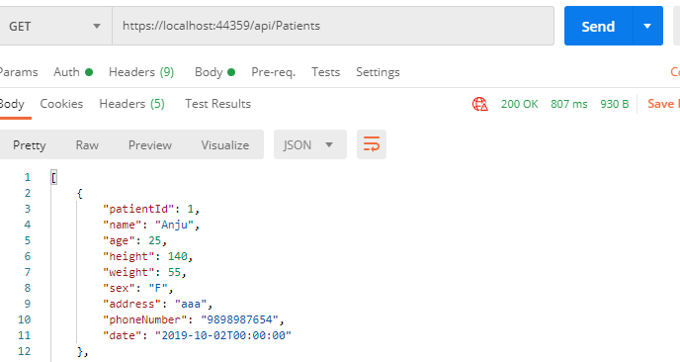
Fig: Patient Controller retrieves data from model and returns view

- Doctors: - Doctor Controller can retrieve data of doctors and gives us the required associated data as view.
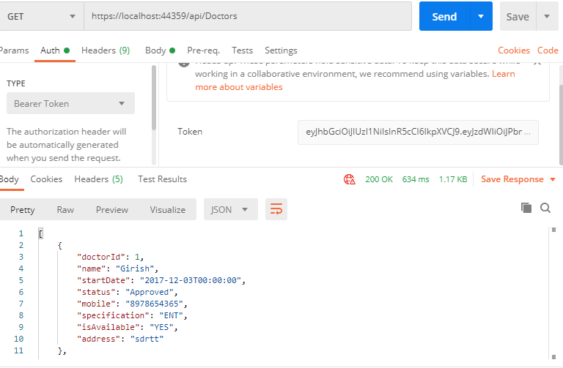 Fig: Admin can retrieve data of Doctors

- Appointment: - Appointment Controller will retrieve data from both patient and doctor model and maps patient to different doctors to see number of doctors are available.

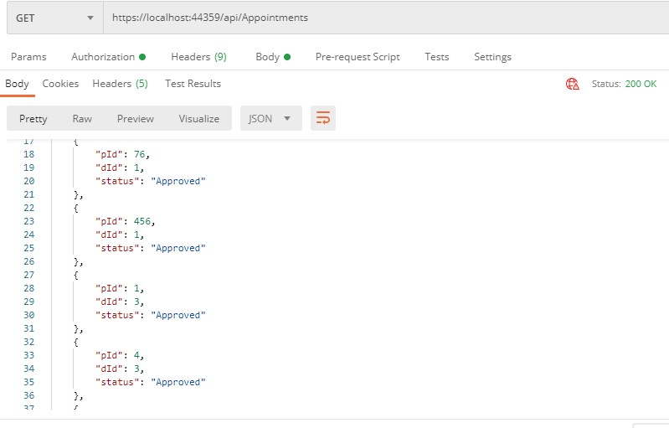
Fig: Patient mapped to Doctor

Conclusion:-
Through Entity Framework data is being scaffolded into model. From model, data is being used by the different API’s (controller) to perform function of mapping of patient with doctor. Data is being mapped and displayed in the view.

